* The benchmark model:

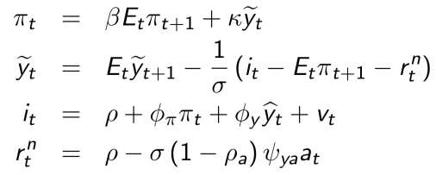

Parameters: 

* The gensys.m solves the state space system, and gives **A** and **C**

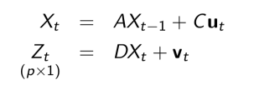

* D and the covariance of z will depend on what observable variables to be included in $z_{t}$.
* For the given state space system, evaluate the log-likelihood, where $z_{t}^{\sim }$ is the innovation from Kalman filter

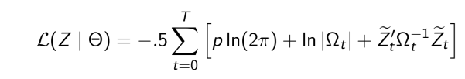

* The code consists of
  + A main program defining starting values for simulated annealing. DSGE_SA.m
  + A function that translates $Θ$ into state-space system. LLDSG.m
  + A function that evaluates $L(z|θ)$. LLDSG.m using simulated annealing: simannb.m
  + Solving the New Keynsian model using method of undetermined coefficients. NKBC_model.m, builds up the linear rational expectation system, and gensys.m solves the NKB model in a state space form. (the two are combined)
  + filter_gap_DSGE and LLDSG.m have the same basic structure. filter_gap_DSGE calls NKBC_model.m and NKBC_model.m calls gensys.m.